West Hull Ladies
RRC

May Newsletter

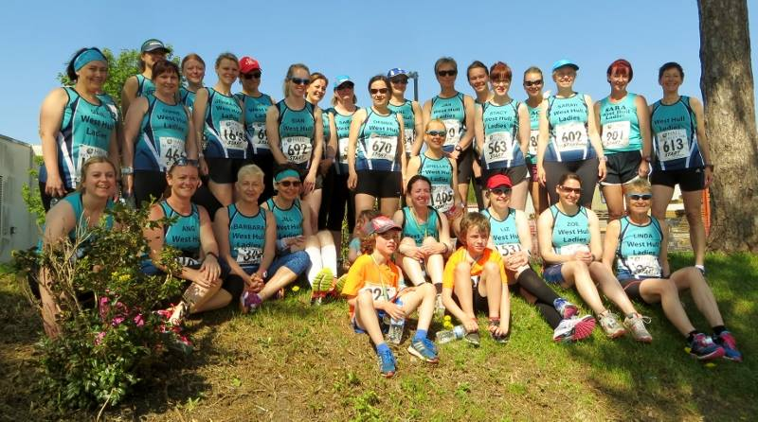

Beverley 10K

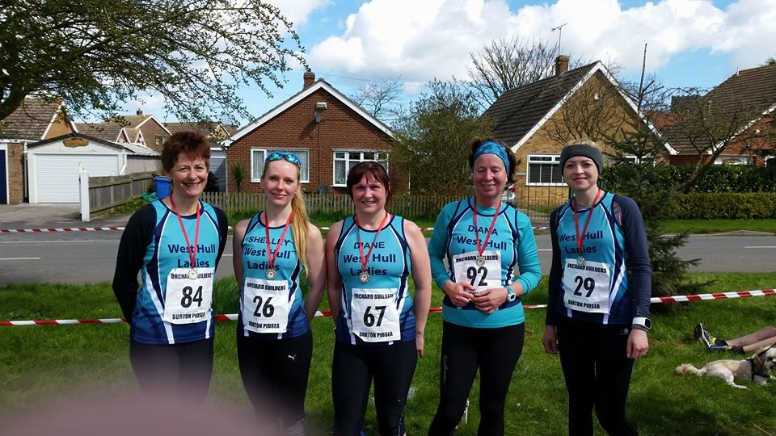
Burton Pidsea 10K

West Hull Ladies
Committee Meeting Minutes
9th May 2016
Apologies from Annette, Anna, Jan
Present Jill, Zoe, Sandra, Linda, Amanda, Liz D, Maria, Shell, Debs

- Minutes of previous meeting accepted as true record.

- All actions from previous meeting - Amanda had emailed steady group to explain integration. Jan had circulated details of away weekend and details of recce of Beverley 10k. Amanda had emailed those ladies who still had to complete membership forms.

- Hull 10k had contacted the Club asking for volunteers to help at the 10k. They would pay £150 for 10 volunteers and less for 5. Shell stated that she would like to volunteer. Action Shell to email ladies and ask for more volunteers. (Done)

- Ros had expressed interest in the Club organising a race in 2017 during Hull City of Culture. This was discussed at length and it was agreed for - Action Amanda to email ladies explaining what was necessary in order for us as a Club to do this. Expressions of interest would be sought to see if it would be feasible. Many volunteers would be needed. (Done)

- A discussion took place concerning training at KC Stadium and the stadium management committee (SMC) saying we could not run around the stadium. The reason given was because of possible insurance implications. Action Sandra to email SMC.

- The GB Relay - Sandra updated that this would take place on the 1st July and we would be handed the baton at 1537hrs in Barton. We then had to hand the baton over to the next leg in Witty Street at 1643hours. Ladies had already been informed of this previously but now it needed to be firmed up. Action Amanda to find details from previous attempt in 2014 and circulate. (Done)

- a) Jill informed Amanda that the Committee and Club were very proud of the fact that she had been selected to represent GBR in the World Duathlon Championship in June. This reflected well on the club and as a Committee we wished to donate £100 towards her costs. Amanda thanked everyone for this donation, which was very unexpected.
b) Amanda would be away for most of June and Annette was happy to do the emails - Jill agreed to prepare and send email on Monday. Leaders completing speed work would send in email to forward out and Annette would prepare and send out Thursday email. Amanda would supply template for these.
c) Amanda suggested we should have another lady trained as LiRF (leader in running fitness) someone who would focus on the new steadier ladies. This was agreed. Action Amanda to progress this.
d) Linda wished to thank Karen for the work she did as member secretary and for keeping the Club up to date with new rulings - non wearing of headphones in races for example. All members thanked Karen
e) Amanda asked if the Club would be interested in organising a seminar given by John Richardson called “Are you tired of being tired” The Committee thought this would be worthwhile and it was agreed for Amanda to organise.There would be a minimal cost to ladies wishing to attend. Action Amanda to contact speaker to make arrangements.
f) Karen stated 5 ladies had still not submitted membership forms and as such they could not be registered with England Athletics. Action Amanda/Annette to contact Ladies involved.
g) Karen informed the Committee of a man named Ben Smith who was running 401 marathons in 401 days to raise monies for anti-bullying charities. He would be in our area 8-9th August and it would be good for ladies from the club to run with him. Action Karen to email ladies with details.
h) Maria gave the following dates when she could lead the steady group 18th May, 1st June and 29th June. Karen also said she would be happy to arrange more reccees of the Humber Marathon route.

Meet a Member : Angela May

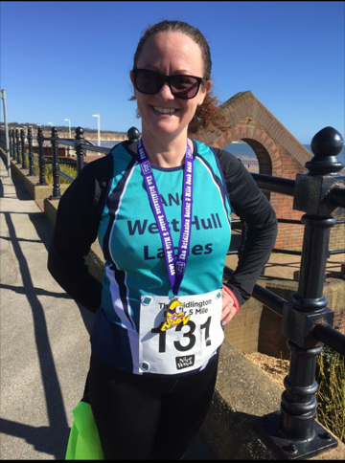

Age- 42
Member of WHL since – Member of WHL since February 2016 after completing the 6-weeks 025k challenge.
What do you do when you’re not running? – (work/hobbies/family) When I'm not running I am a wife, a mum to two girls (ages 10 and 12) and busy balancing work and home life. I support my youngest daughter and her football team (Cottingham Rangers) and I like to get to Hull City Ladies' football matches as often as possible. I love Facebook, Instagram and Twitter for positive networking and sharing news. I work part-time as an Administrator for the East Riding School Sport Partnership (West). Our office is based at Cottingham High School. I am the facilitator and provider of transport/social life to my girls! I also enjoy walking with our Springer Spaniel Jake. I enjoy spending social time with our families and I'm rather partial to gin! ;o)
How long have you been running? –I have been running on and off for years - always on my own though, never as part of a group.
Favourite distance – I don't have a "favourite distance" yet, that's still to come but I'm hoping to get beyond 10k in the future.
Favourite bit of running kit – My favourite bit of running kit, at the moment as I'm still a newby, is my compression socks. I have found these to be invaluable for recovery.
Any injuries? – I had a really bad calf strain a couple of years ago (I felt a pop as I was running) and it was hugely painful. I had a tantrum and threw in the towel when I didn't feel like I was making progress or getting better. On hindsight, I was doing too much too soon. So, I went off and learnt salsa dancing instead and thoroughly enjoyed that but running was always there at the back of my mind.
Running goals? – My running goal is to complete a 10k in an hour. I have already entered Beverley and the Jane Tomlinson in Hull plus I have my eye on the Scunthorpe 10k and possibly the Leeds 10k with a group of colleagues (to raise money for a charity).
Proudest moment running related or otherwise – My proudest moment since joining the club was completing the Bridlington 5-mile dash in 50 mins 13 secs. I was absolutely over the moon! Aside from that, the girls make me proud every day when I see them achieving and growing into independent individuals. They are like chalk and cheese so there's never a dull moment!
Best piece of advice you’ve received – The best piece of advice has been to accept that I may not be as fast as other ladies and that I should run at a pace that is comfortable for me.
Running alone or with friends? - Before I joined the club, I thought that I was a lone runner and had convinced myself that I preferred running alone. How wrong I was! Running as part of the group is the best thing that I have ever done.
What keeps you motivated? – Being a member of WHL keeps me motivated. I am there Monday, Wednesday and Friday and I love the variety of the sessions that we have. I have been running three times a week since I signed up to the 025k challenge albeit I had to begrudgingly miss two Fridays for social reasons! I find myself wanting to go out and run at weekends, especially when I see what everyone has been up to on Facebook.
2016 has been a great year for me, thus far and I am so happy to be a part of WHL. Thank you all so much for your warm welcome.

Meet a Member : Dehanna Davison (Dee)
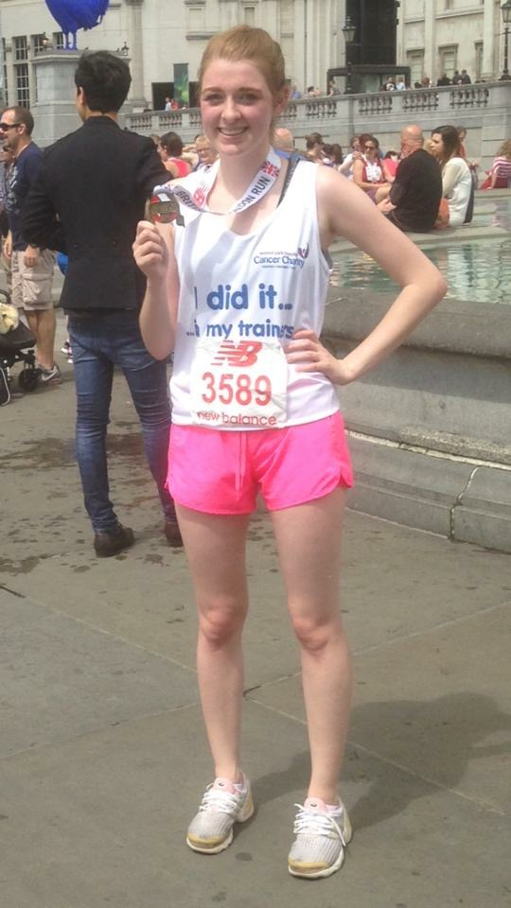
Age – 22
Member of WHL since – January 2016

What do you do when you’re not running? – (work/hobbies/family) - I'm mad enough to be interested in politics, so spend most of my time either studying for my degree or out delivering leaflets and knocking on doors. I have also stood for a few elections myself, including in Hull North at last year's General Election. When I'm not doing that, I'm normally with my fiancé watching bad action films or visiting my Godson and other close family in Sheffield.

How long have you been running? – on and off since about 2013

Why did you start running? – I signed up for a 10k to raise money for charity so thought I’d better do some training!!

Favourite distance – 5k
Favourite bit of running kit – My fluorescent pink shorts!

Any injuries? – The odd knee twinge, and an occasional twisted ankle from my sheer clumsiness!

Running goals? – To run a sub-2 hour half marathon one day.

Proudest moment running related or otherwise – Finishing my first 10k by running past one of my favourite buildings, the Houses of Parliament. (I also raised over £500 for my dearest charity!)

Best piece of advice you’ve received – “Just keep going. Slow down if you have to, but don’t stop, because you’ll find it hard to get going again.”

Running alone or with friends? – Bit of both really. If I’m alone, I have to listen to music though!

What keeps you motivated? – Thinking about that next bar of chocolate! (That, and I’m really competitive and like to beat my own times!)
Manchester Marathon : Jane

I spent the Saturday feeling totally shattered with zero energy, so was relieved when I awoke on Marathon day feeling fine & dandy. Up at 3.45 for breakfast of porridge, linseed, banana & honey with the important cuppa. Liz arrived soon after & we were on our way to Manchester.
As we came off the motorway we soon realised that satnav's are no good with road closures. The signage for the Marathon were few & far between so we parked up & looked at the map again. We were soon headed in the right direction & knew we were in the right place when we stopped in a huge traffic jam for the car-park. Time was ticking by so we found a small shortcut but we were moving very slowly. Eventually we saw the entrance to the car park, it had taken us 40 mins. Now it was a race to get to the start. The baggage queue was a sea of people jammed together. We got told to just leave our bags in a pile & they would be sorted, so after a long needed toilet stop we ran to the start.
The race had already begun when we joined our time slot at the start, which wasn't a problem as we were chipped. I crossed the line, my marathon had begun. I checked my garmin & I was on pace & moving comfortably. I remember talking to myself (this is normal for me ladies) I was actually enjoying it. The atmosphere was buzzing. The support was uplifting as we ran through villages and people were shouting encouragement at you as you trundled on. I had decided to run through the water stations & see how I went after that. I got a shock, my hips certainly didn't feel normal, it was a relief to start running again. There seemed to be children lined up every so many miles handing out sweets, I declined jelly babies but the jelly beans were welcome.
I paired up with a lovely lass called Sarah from Cardiff she had fallen in the first half mile so was nursing a bruised knee, however we both carried on chatting as we went until eventually with walk breaks from either side we lost each other. I was trotting along nicely when I heard my name called & Helen from COH ran passed me while shouting encouraging words "Come on Jane you are doing great". She was doing a 2 man relay. This perked me up.
I found that in the last eight miles my neck & ribs started aching quite badly so I did my MOT's to no relief. My shoulder & nerve In my neck were throbbing as I trotted on. My legs were pretty shot but they were the least of my worries, my feet were sore but this I could live with. It was the shooting pain across my rib cage & top of my shoulder that was causing me problems. I had to walk to try to ease it but gave up. The last 3 miles seemed like 6. Would the finish ever be in sight. Finally a steward announced that round the corner the finish would be in sight. Yippee it was but still seemed so far away. One last push, but it never seemed to get any nearer. 200m to go. You will be pleased to know that even after 26 miles I still managed to up my pace to arrive over the finish line in true WHL style. I'd done it. The medal was warmly placed round my neck with kind words of congratulations as I made my way to holding area.
I collected my goody bag & more water before I reached the Erdinger stand & helped myself to a pint of Erdinger non alc. It was like heaven. I reached the massage tent & waited for Liz. After sometime I joined the queue for the baggage which was huge. Liz appeared having just collected her bag & went to get something to eat & wait in the car for me. The queue was moving which was a good sign but it was like a wind tunnel so not very warm. I got chatting to a lovely couple for Colchester. It was her first marathon & she was elated having done sub 4 hours! Wow! Her husband very kindly fetched us both a couple of foil blankets which warmed us up. When eventually got my bag back I met Liz at the car. We were joined by the lovely Roz & her fella Bob. They had missed their train having to wait for their bags.
We all chatted happily on the journey home. Stopping briefly at a services to get some food. This had been an amazing experience. Brilliant company and encouragement from everyone.
I've finally completed my first marathon in 5.19.49 which left me feeling totally elated.
I didn't think anything else could top my day until I got home. Waiting for me was 2 gorgeous bunches of flowers, a large bag of maltesers & my wonderful husband had made me a post marathon meal which consisted of hard boiled eggs, salad, sweet potato wedges with lamb steak.😘
A huge thank you to everyone for all your support and encouragement throughout my marathon training especially my running bud Sarah Frost who put up with me for 16 weeks. Thanks Hun for keeping me going in all weathers & being such a fantastic mate & training partner. I know I said never again but all I say now is watch this space! 😜🏅😃
Jane

Brighton Marathon: Rachel A
The road to Brighton Marathon 2016: A lesson in never giving up!

As I hobbled away from my 1st marathon last April, with an injured left knee and a time of 4:05, I set myself the goal to get myself injury free and return in 2016 to run the same course in under 4 hours. My knee pain had made the final miles of that race highly unpleasant, but after seeing a podiatrist for specialist orthotics my knee seemed to be fine and I went on to run some good PB times over shorter distances.
The first sign that the road to Brighton 2016 was not going to be straightforward came when, at TR24, pain in my other knee meant Linda and I had to pull out after 60K each. Then, whilst in Greece, I ended up having an emergency abdominal surgery. This meant September/October involved no exercise at all and November/December were spent desperately trying to regain fitness, but now I seemed to be plagued by pains in my left calf. Jamie said it was the insoles, but I was worried my knee pain would come back if I got rid of them. Xmas arrived and it was time to start marathon training, but week one of my 18 week plan ended up with zero miles and, with Brass Monkey and Ferriby 10 booked for early January, I wasn’t feeling optimistic. Out of nowhere, my injuries held off and I managed to run PBs in both races! However, the hills at Ferriby had created a dull niggle in my right hamstring and a hilly 17 miler a week later led to my right knee pain resurfacing. I ended up with yet more zero miles training weeks and now had knee/hamstring issues that just wouldn’t go away. With 9 weeks to go, I cursed Jamie for quitting physio and booked in to see Kris. I thought he’d tell me that running the marathon was insane. However, he surprised me with his positivity and believed that weak glutes were to blame. So, since February, I have been doing 20-30 minutes of glutes exercises every day. I also pulled out of most of my remaining pre-marathon races, stopped doing speed work, ditched my expensive orthotics, and slashed the number of miles in my training plan. I focused on doing pain-manageable long runs, topped up with easy midweek miles. I ran laps of a 5 mile loop so I was never too far from home. It was so boring, but my pain-manageable distance was increasing so it seemed the strength work was paying off. Throughout these exceedingly frustrating months WHL proved amazing. Many of you sent messages of support and Karen, in particular, put up with almost constant depressive moaning about my injuries!
Just as the taper started I realised my right leg felt almost normal again. This meant I could pick up the pace across some shorter runs and a little voice in my head reminded me of the goal I had set the previous April. So, rather than pull out of Hornsea 1/3, I decided to run it and was happy when it felt okay. With a week to go, I formulated a cunning plan, with very specific splits for each of the 26.2 miles that meant I could slow down if the knee pain hit in the second half of the race.
Marathon weekend arrived. Karen and I had a great journey discussing strategies, followed by some serious carb loading and enjoyable shopping. We spent the whole time laughing about how we didn’t feel like we were here to run a marathon. Travelling with a good friend and fellow runner seemed to really quell my nerves. As we headed to the start on Sunday we noted that there wasn’t a single cloud in the sky and that it was going to be warm. As we joined the longest toilet queue in the world we realized that the race had started and my corral was about to leave. So, a quick hug and I was off. I desperately needed a wee, but the race was on…
The first mile was uphill, but all I could think about was needing a wee! After a mile my left calf was tight and I just hoped it would wear off. It did at mile 4, but then my left foot went numb and I felt like I was running on a stump. Luckily that only lasted for about a mile! The sun was out and it was already hot, so I made the decision to take water at every opportunity and hoped that I’d find a portaloo without a queue soon. By the time I did find one (mile 8) I no longer needed a wee! The miles slowly ticked by and the sun got hotter. We were heading up a very long gradual incline that never seemed to end, but I was sticking to a decent pace. As I headed downhill from this ‘out and back’ section I saw Karen across the way and we gave each other a huge wave. I crossed halfway in 1:55 and I felt strong. The next stage was to tick off miles 14-20, but the knee was starting to niggle. I tried to concentrate on my form, keeping a neutral spine, picking my knees up, and ensuring I wasn’t overstriding. It seemed to keep the pain at bay. Miles 20-24 has the route heading out around a rather desolate power station. I was now in the midday sun with no shade. I did slow down a bit here, but I also knew these were the hardest miles because there is little crowd support and lots of people start to walk. I just had to hold on; I was still getting niggles in the knee, but I told them to shut up and just pushed onwards. By the time I got to mile 24 I knew that, barring a complete disaster, I had done it. I hadn’t need to slow as much as I’d planned for and the toughest part was over. This is where the crowds start to pick up again and you run along with the beach on the right and pretty painted beach huts on the left. I had been crying with pain at this point last year, but this time I felt strong enough to pick up the pace and overtake a lot of runners. Disaster did nearly strike though! At about 25.5 miles the knee started to seize completely. I swore out loud (possibly in front of small children… oops) and let my stubbornness kick in. I pushed the pace even harder to the finish. I’d have been ecstatic with 3:59:59, but couldn’t believe that I’d actually finished in 3:54:38.
After the race, I lay on the beach for a while, examined my lovely new toe blisters, enjoyed some banter with other runners, and then had an anxious wait for Karen. She’d texted me to say the heat was getting to her and I couldn’t get the tracking app to work. However, she did WHL proud and battled through some really tough times. That, however, is her story to tell. Our journey home was filled with yet more laughter as we navigated trains and tubes with post-marathon legs – ouch!
I suppose the moral of my story is that, sometimes, things can feel very bleak. At my darkest point I cried and told my husband that I was quitting running because my body couldn’t do it properly. But… with the help of very patient family and friends, a wonderful supportive running club, two great physios, and a huge dose of stubbornness… I didn’t give in! Two days on from the marathon and the knee is absolutely fine, although the toes might need a bit longer! My next step… even more glutes exercises… I need to be ready to deal with some unfinished business at TR24 and then Berlin Marathon in September…
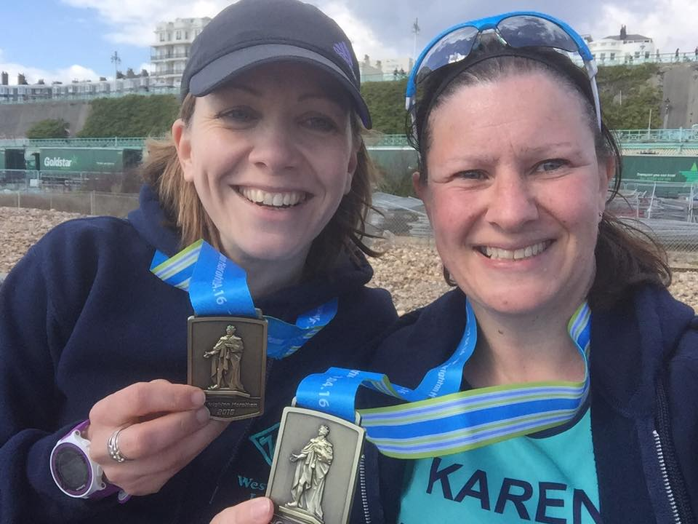

London Marathon : Sandra

After running Berlin Marathon in September 2015 in my slowest time ever I felt very demotivated and I fell out of love with running. I am not sure if I was just very fatigued after running 3 marathons in the space of 12 months but every run after that was hard and it just wasn’t fun anymore.
My training for London started at the beginning of January and I knew that unless I got my love for the sport back then it would be so hard - maybe too hard.
So I went back to basics and went for runs that didn’t tax me too much. In November I trained on 10 occasions and in December after going abroad and running there things seemed to click into place again. I was enjoying my running again.
Monday January 4th saw me start my 16-week training programme. I cannot tell you how good it felt to manage the full 16 weeks with no injuries (save for a strained shoulder muscle). Usually I tend to do my training alone as I like to go from home but I ran a few long runs with Jermaine. Training where I do it is difficult to run a marathon pace as you are told to as the courses are so undulating. My times on the long runs were quite a bit faster then when I have trained alone. Speedy Jermaine was making me go a little faster than I normally would. This at times was a bit scary, as I didn’t know if I was overdoing it on my long runs. But it felt comfortable so it must be ok?? I didn’t really know and come race day although I had an idea of what time I wanted to run I wasn’t too sure what I could or couldn’t do.
So on the Saturday I travelled with Linda on the coach to London. Other members of WHL’s were also on the coach either running or supporting. My husband and daughters were travelling down on the train and staying in Central London.
On the Sunday we were up early and after a breakfast of porridge, coffee and beet it juice we were taken by bus to the start. Linda and I were going from the Green Start, which was quite civilised as only about 3000 go from that location. No toilet queues to start with - we got a drink and went to sit on our bin bags in the changing tent to await the start.
As we went to the pens we met or rather Karen Scott found us. It was lovely to see her and gave us a huge boost.
And then at 10am we were off. We were so lucky with the weather - snow and sleet had been forecast but apart from it being a bit chilly and windy it was great. It took me 3 minutes to get across the start and then we were off. I tried to maintain a steady even pace. At about 2km I cockled over and was a bit worried about the pain in my ankle but within a short space of time it felt okay. Just look where you are going Sandra.
I was then worried about Linda because the course was crowded with runners who were bumping you and crossing in front of you, clipping your heels. It would have been so easy to fall.

I then started thinking of Berlin - it had been very similar to this with severe bunching at turns in the road. In Berlin I gave up at 11 miles. What was different this time? I actually think I was hungrier to get a good time for me and go under the 4 hours. At that time I really believed that this was going to be my last marathon ever. My strategy for running was to have a gel every 4 miles and between about 18-20 miles to slow a little to conserve some energy to run and push the last 6 miles. For me this worked really well. When I had my gel at 16 miles I was thinking ‘only 2 more gels and it’s in the bag’.
I was trying to run tall and kept telling myself ‘work hard’. I really did try to do this.
I am not sure when I heard a loud cheer from our lovely supporters - possibly about 21-22 miles. I turned round and saw them all. What a wonderful sight and I could feel myself pick my legs up and get a little quicker. I did have to tell myself to slow down - still a few hard miles to do.
As we got on the embankment I started looking for my family. I couldn’t see them, which was not good. But it was maybe better I didn’t. I could feel cramps crawling up my calves and feet. If I stopped I am not sure they wouldn’t have hit me full force. So come on Sandra pick up your knees not far to go work hard you are nearly there. It felt wonderful turning into the Mall and seeing the finish.
I was so happy and so very tired. The medal was put round my neck - it was heavy as was the goody bag. Everything was so calm and organised. I got my bag and waited for my family and Linda at Admiralty Arch. It was so good to see them at the end but we only had about 10-15 minutes before they had to go get their train home. That was a pretty sad moment for me.
So I have to say I had an absolute ball of a time and although it was hard and the training was hard it was so worth it. If this was my last marathon then I went out on a high. A massive thanks to my training partner Jermaine and for all West Hull Ladies for your support. I also would like to thank the 0-5k steady ladies. You may not have realised but you were doing me a massive favour because the runs that I did with you I believe helped keep me injury free.
So that’s it - my marathon adventure is over. (For now!)
Sandra

London Marathon: Linda
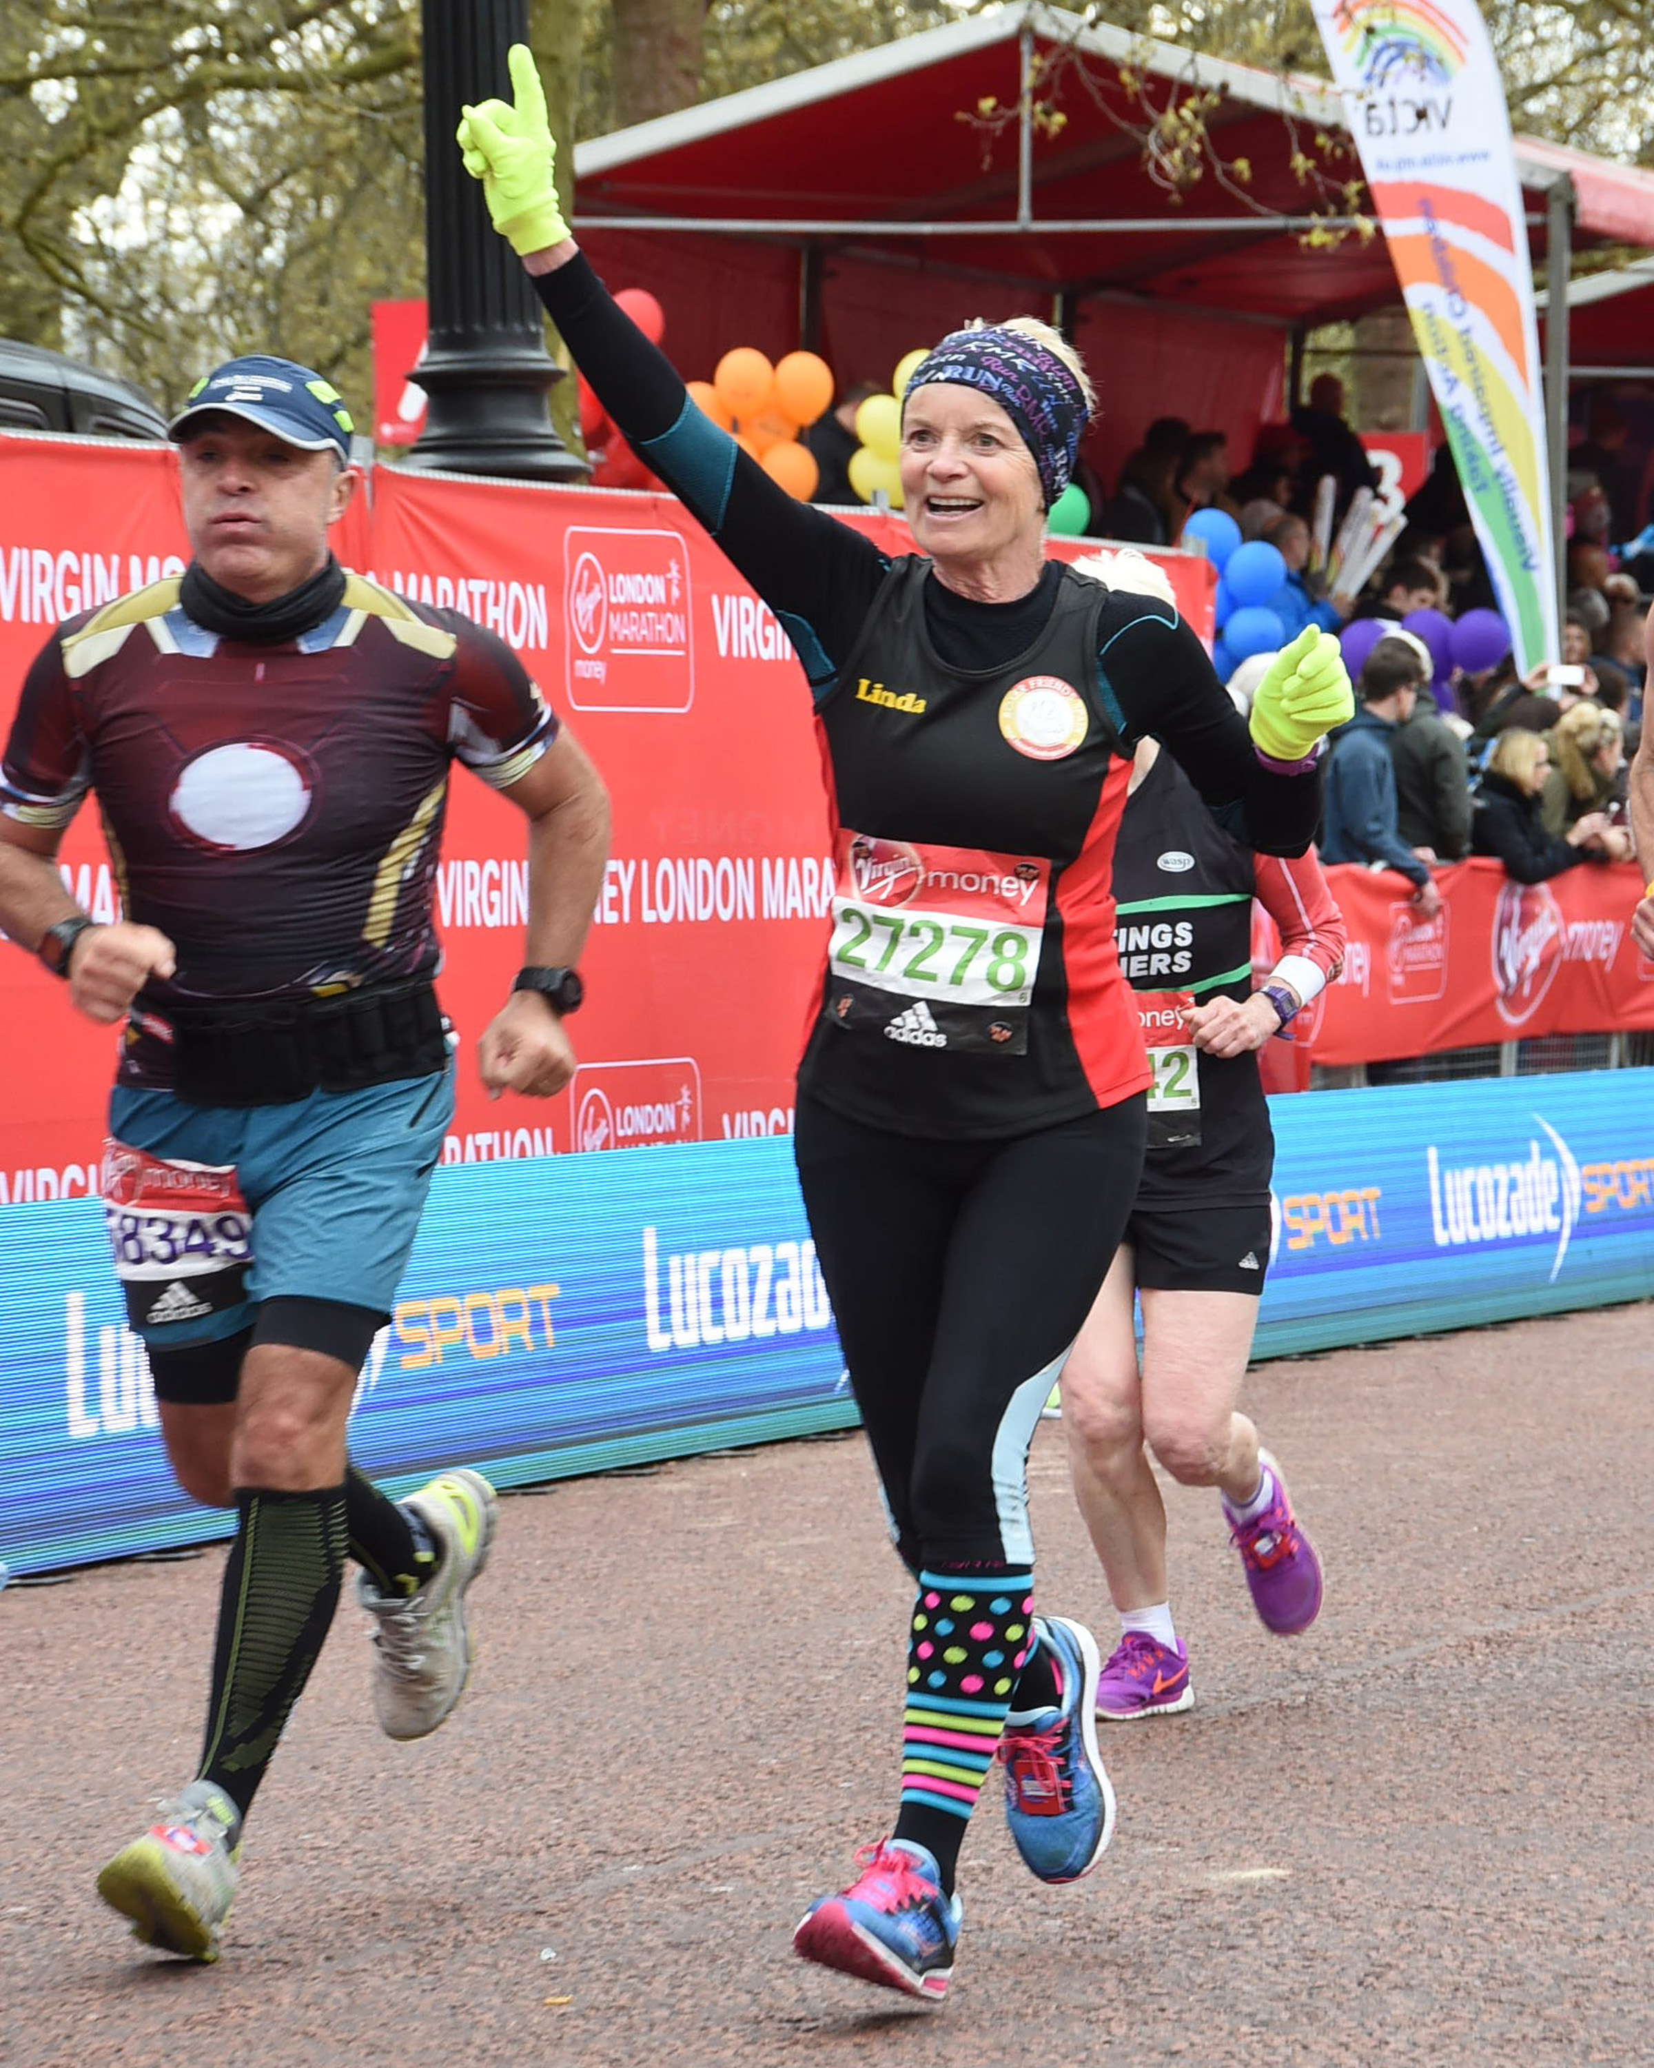

I managed to get a place for this marathon by getting Good for Age at the York marathon in 2014. Sandra also got GFA and we decided to go together. Although Sandra ran Berlin in 2015 and she said she would never run a marathon again, so sorry Linda I won’t be joining you!
Well that was a little fib because she did join me on the COH bus on the Saturday before the great day along with other WHL, Sarah Frost, Rachael Laughton, Debbie Watson, Sally Widdowson and Sara Ellis. Karen Scott, Rachel Whittaker and Fatma travelled by train. It was a jolly little coach trip and Rachael won the bingo twice, well done to WHL.
Arrived at the Expo in the afternoon for registration and a look round, I was good I didn’t spend too much money and neither did Sandra. We had our photo’s taken in various places and met up with Fatma for a hug. Then it was back at the coach for the evening meal and an early night. The food was fantastic, I wanted to eat more because it was so nice but I was very careful knowing what I had coming up in the morning. Early to bed although we didn’t sleep very well. Something to do with nerves and excitement.
Up nice and early, shower, dressed in our running kit and off we went to the start. I’ve never ran any race where there were so many people, it was awesome and frightening at the same time. Because we were GFA our start only had around 3000 people so we could relax in a tent with a hot cup of tea huddled up on a bin bag (so glam) but at least we were dry and warm.
All too soon we were lining up in our pens for the start. That was when we heard an excited squeal from Karen Scott, OMG how did she find us, couldn’t get a proper hug as we were behind bars but it was fab to see her knowing that she’d sent off Paul with his 40lb back pack off on his little jog around London. How fab is he.
Then we were off, the butterflies left me and I tried to concentrate on my pace, that was hard because I felt so good I just wanted to run, and run, and run, but of course I knew I would break down early if I did that! After mile one we were joined by the blue starters, that was fun there was a lot of booing (in a friendly way) when they joined and then we joined up with the red starters at mile three, again lots of booing banter. The crowds of people watching and the crowds of people running were awesome although you did have to watch your footing because of the amount of bottles that got thrown down at every mile.
Cutty Sark, what can I say, that was magnificent and the crowds there were so noisy, it made me cry (I just knew this would be an emotional day)! Onwards, waving and hi fiving children that were holding out sweets for us runners, everyone shouting my name it was amazing. My next awesome moment was when we came round the corner to Tower Bridge, I thought the noise at Cutty Sark was bad but oh boy this was even more amazing, I cried again! I think I even did a little dance over that bridge when I heard the music blasting out.
I tried to keep within my marathon pace but I think I went off too fast, I lost it a bit at mile 18/19 and I needed a wee too (or I thought I did), we were approaching a tunnel which was dark and no spectators down there, no queues at the loo so off I went. When I shut the door it was pitch black and as you all know there is nowhere worse than a portaloo at any race without having to go by feel which I did, yuk. I must have lost over 5 mins in there as getting your gear back comfy again is nigh on impossible!
Anyway I picked myself up and started running again, not far to go now oh look the mile 20 board, only a 10k left (bloody hell that is a long way), oh look I’ve got to mile 23 only a parkrun left (the longest parkrun in history), it was this point that I saw the poor chap on the floor being attended to by paramedics, it made me feel sick and I did stop for a walk/stumble while I cried, I just knew the outcome would not be good. What on earth are we all doing to ourselves, we must be mad!
Then It was Big Ben, not far now and that was a beautiful sight. The crowds were even thicker and the noise deafening and hearing my name being shouted out every which way. Then the 800m board, oh boy only twice round the track that is not far now, picked up my pace got it back up to 9min a mile but my legs were screaming at me to stop! 600m smile Linda you’re almost there, you can do it. Then the all important 385 yards picked up even more raised my arm and focused on the finish tunnel. Amazing I did it, I can’t believe it. I stop and my whole body goes into a spasm of wobbles wondering what on earth I’m doing! Then they put a heavy medal round your neck and present you with a carrier bag so full of stuff it looks like you stopped at ASDA on your way round, suddenly you’re shattered, you’re crying and you’re weighed down and look like an old woman.
Found the lorry with my bag on it, that was an amazing bit of co-ordination, how on earth did they manage that after seeing them throw the bags onto the lorries at the start Sandra and I were worried we would never see them again and suddenly you have a nice young man handing it over to you all in tact.
Warm clothes on, text Sandra, find Sandra and her family, cry like a baby, have a hug from her while she cried too and from her two beautiful daughters and her lovely husband. We then made our way to Starbucks for a much needed cuppa, then we found the coach (that seemed like a long walk but it wasn’t)! When we stopped in the services we treated ourselves to a BIG MAC MEAL. Just what the doctor ordered.
I would like to say a huge thank you to each and every one of you that helped me get to London, without your encouragement or accompanying me on long runs I would never have made it. Geeing me on at the Track, at races, during all kinds of training sessions. This would not be possible without WHL. A massive thank you to my weekend partner Sandra, she is one wonderful WHL star.
NEVER AGAIN though! Oh look Sandra has messaged me, shall we enter GFA next year and defer until 2018 so we can run it in my 60th year? YES Sandra let’s! (haven’t told hubby yet)!
Linda x

Hornsea Third : Sharron

I wasn’t sure whether to enter this event, but our Karen Scott can be rather persuasive at times…… So I thought, why not! Karen said to me that we’d run it together and by hell, true to her word, she never left my side once, bless her! Felt quite nervous for this one, don’t know why, probably because I’d never ran this particular mileage before in a race and wasn’t sure how to go about it. To be honest, I never know how to go about ANY race as I always start too fast, then just hope I get to the end….somehow. I’m really going to have to learn how to pace myself correctly!
Anyway, we did roughly a half mile warm up by running to the start line. I thought I wouldn’t stop and start my watch to accommodate this, as it was just over half a mile. Even WITH all the digits after the point; I’d be able to work out how many miles I’d covered every time I looked…..????........SURELY…..????? Well a few miles in, probably through some kind of brain storm kicking in I just couldn’t work out the mileage at all!! My brain just wouldn’t work………Thankfully the mile markers were out and noticeable so I relied on those! I’ve learnt a lesson there……(though obviously NOT HOW TO SUBTRACT!!!)
The race started, Karen said she’d fall into my pace but I did what I always do, I started fast, too fast really. After nearly 4 miles I heard Karen say to me “I daren’t tell you the splits of these first 4 miles…..” which kind of made me think, hmmmm, let’s go slower…… To be honest, the first 3 miles felt ok, I knew I was running faster than I would have if it were just a normal training run. The 4th mile in I did begin to feel it but I also knew the warmth had a lot to do with that.
It WAS a very warm day, first run out in heat like this and I was willing the water station to come round quickly. I remember thinking as I was looking longingly at the puddles by the side of the road, I wonder if people would judge me if I took a dive into them and quenched my thirst…..???!!??? I was saying “I need water……….I NEED WATER” Talk about being a drama queen……..
Anyway, after around 4 miles….yes 4 miles in was the one and only water station (what was all THAT about???) I gladly took in some water. I remember saying to Karen, I’m going to take the rest of the race steadier, and I did.
I think I got into a good rhythm stride-wise and breathing-wise after that. Then we came upon the many many MANY hills (yes maybe a slight exaggeration there…….???!!???). Where did those come from?? Occasionally Karen would say, “I’ve just looked into the distance and I hate to say it, but ………………” “YES.….I’VE…..SEEN…..IT.” I would pant back. Karen could hear the changes in my breathing and being the fantastic coach that she was would help me get back into rhythm again once we’d reached the summit of that particular mountain….……….. J
All in all, 4 to around 7.5 miles seemed to go ok, yes my legs were tiring but they were working in some way, shape or form still. 7.5 miles onwards seemed to take FOREVER. I kept thinking “I wonder if I can just walk a bit” then I’d think “Get a grip woman, NOBODY IS WALKING, you’re NOT going to be the first person seen to walk” Then, at around 8 miles, just at the right time we happened upon 3 lovely children……..I saw them up ahead and, just like a child myself, I found myself thinking “are we nearly there yet, are we nearly there yet” then, as we ran closer, 2 of the older children caught sight of us, shouted SO much encouragement to us, it was unreal and then proceeded to high five us…………THEN a babe in arms (with help from his mother) high fived us too!!!!! Spurred on by this and the rather disturbing statement from Karen of “Sharron, you’re really not going to like me for this last half mile to the finish……………….” (Errrrrr……what you going to do to me Karen????????) She shouted “C’mon, you can pick the pace up, you’ve got it in you, you can speed up” She reached for my hand, pulled me along for a while until, by some miracle, my legs DID seem to be going faster. I then saw the finish, I DID find that something in me and sprinted(ish) for the finish. Yay!!!
I was so thankful to Karen for spurring me on those last few yards, I really was and I just about held myself together at the end and not blub! The reception from all the other WHL was fantastic, we laughed, we hugged, and when we’d collected everyone up we headed back towards the carpark where we all went our separate ways.
I’m glad I ran it, I’m so thankful to Karen for sticking with me and getting me round, I couldn’t have done it without her (or I maybe would have walked a while). I’m so pleased with my time, I really am. I didn’t really have a time in mind, like I say, because I’ve not done this particular mileage before, but I was so pleased to get in under one and a half hours (1 hour 29 minutes 41 seconds!!).
It took me a while to get my head around the fact that there was only one water station and it was a warm day……… but other than that it was very well organised and very well marshalled, they were all happy and encouraging too, which was nice.
Sharron
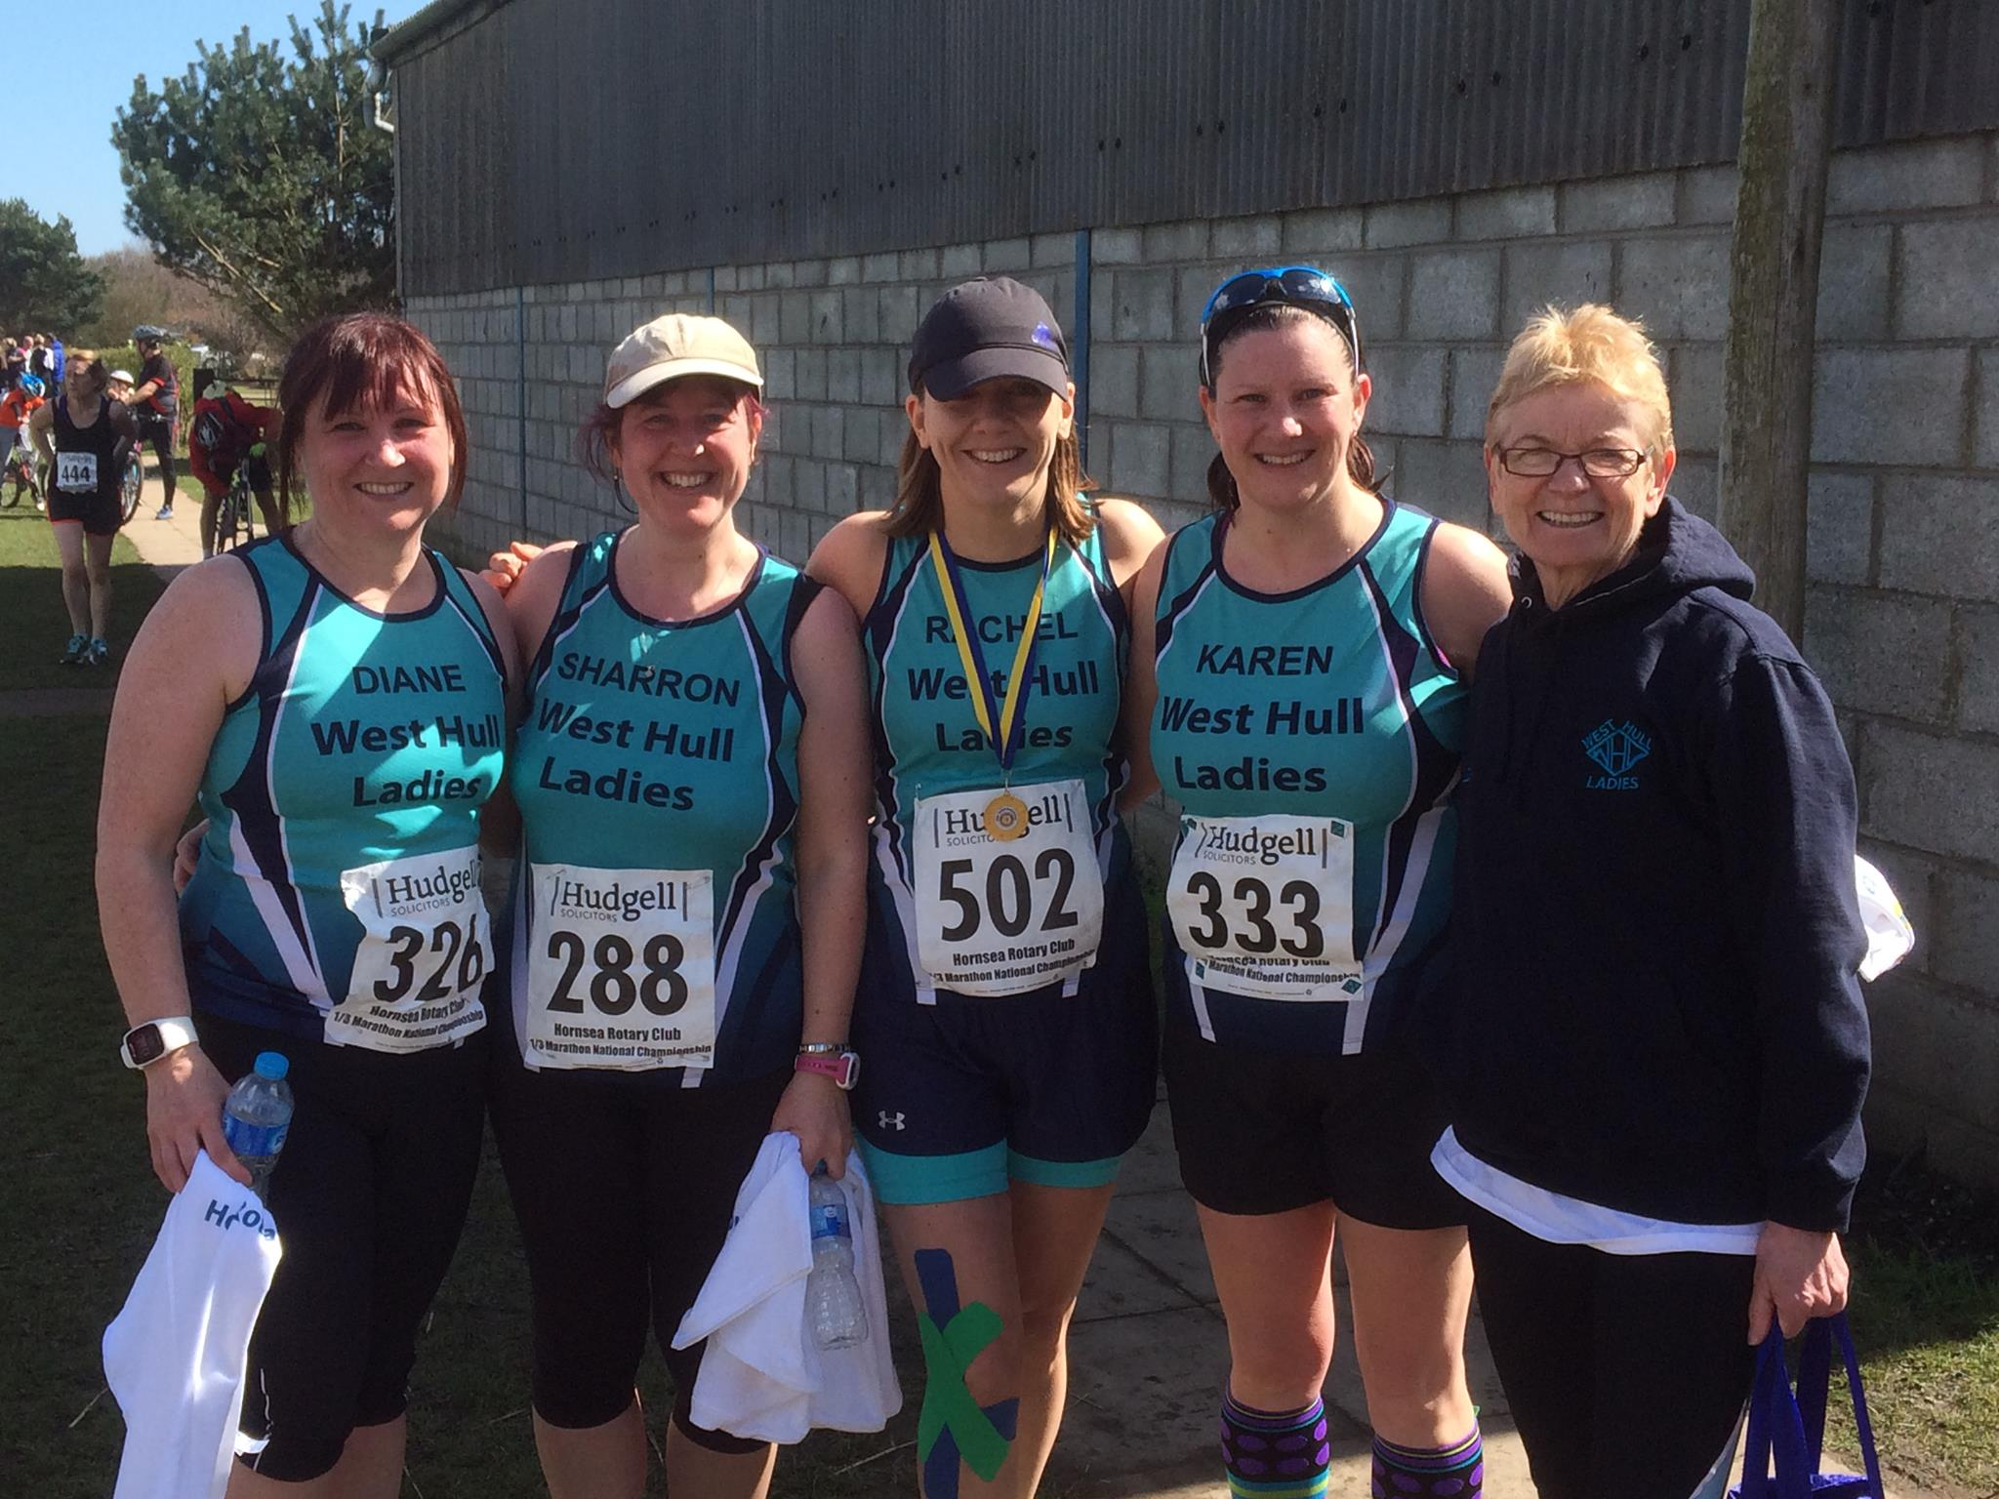
York Triathlon : Liz H
This time last year I completed my first Triathlon at York, and I was determined to have another go at this event but this time to take on the Sprint longer event.
This year I was joined by Jill and Zoe as well as husband Chris now a seasoned Tri-athlete.
The day started well with a snow and sleet shower just after we got up! The weather did improve but we there was a really cold wind all day. Chris and me
arrived in good time, parked up and went to register and grab our numbers. Note for next year we really should have made the journey to get our numbers on Saturday as Zoe and Jill did. I have done a couple of Triathlons now and I have never seen as many numbers to stick in various places; added to the normal
race numbers to put on your belt or vest, there was 3 stickers for your helmet, one for your baggage and two for the bike as well as two sets of “tattoo transfer” for your arm and legs. The tattoos were especially challenging for a numpty like me, as I managed to put my leg one on upside down so instead of it being
391 it became 163 whoops! After much swearing and general gnashing of teeth from both of us particularly as Chris managed to lose and then find his
transfer and was very pushed for time, he grabbed his transition bag and jumped on his bike to get to his starting point, in time. I followed at a more sedate
pace as I was on nearly 2 hours after him. This meant I could take some pictures of him and then hopefully hand over photography duties to him when he
finished.
I was really happy that I had taken my big winter coat as the site is very exposed to the wind, I had already changed into my non matching two piece tri-suit,
(none matching as it was cheaper!), and was wearing it under my coat. The course is 16 lengths of the pool, 18k bike ride (6 there and backs on the course)
and a 5k run (4 circuits of the run course). It's up to you to keep count! I took photos of Chris and met up with Jill and Zoe, as Chris was finishing his bike ride.
Jill gets very nervous around water and worries about sinking, I find this slightly amusing as I get nervous around running particularly getting lost on long runs.
Jill and Zoe went to rack up their bikes while I waited for Chris to finish as he did, we did a quick swap of the camera and I did a strip off in an extreme cold and
exposed bike transition area, so I could then give Chris my coat. As I stood there shivering two ladies who were doing their first triathlon started to ask me
about the event, I have to confess I was polite, but was not feeling very jovial about their questions!
Eventually I went into the sports centre which was positively balmy in comparison, I saw Zoe who was on after me and was waiting for Jill to change and after the compulsory loo stop I was ready to go. The pool is divided into 4 and you swim each lane 4 times before moving to the next one. You have to attend the briefing about 15 mins before your start, and Jill was just about 3 mins after me so we sort of attended the same one. You then get into your number order and they set you off every 30 secs. I was happy with my swim, but as usual started to swim as fast as I could forgetting that with swimming a long efficient stroke is better than small ones, it's sort of the opposite to running really, where you are trying to keep your cadence up. I tried to go underwater under the lane markers but kept getting stuck under them, also a faster lady than me overtook me at the end, ducked under the lane marker and then loitered there so I was stuck underwater waiting for her to get out of my way, it's probably just as well you can't swear when under water. The good thing at York is that as you end in the corner of the pool you can use the steps to get out, due to my general lack of co-ordination and of course the now famous, (thanks Chris), short little legs,
jumping out of the pool in one effortless leap like most people seem to be able to do is out of the question. At Drax triathlon I gave up trying and swam to the
steps much to everyone's amusement!
You then have to go outside round the centre to the bike area and believe me when you are wet from the pool the you realise how cold it is, you also have to
run with bare feet on the concrete, ouch. I found my bike and began to sort out my socks, compression sleeves and trainers. I have to confess talc is useful
but I think I had gone a bit mad, my black top was now liberally speckled with white powder, good job I was doing a triathlon and not attempting to go through customs!
I got to the mounting area and got going wondering how long it would be before Jill would come flying past me, I was pleasantly surprised to have got well into my first circuit before I heard her familiar “Come on little short legs keep going!” and then she was off into the distance! I kept spotting Chris who
was doing the photos and also Zoe at one point as well. I was pleased that I had remembered to set my watch because I started to forget how many laps I'd
done. I also found that I could go off brick sets, they look nice but in some places were loose and wobbly and not great to ride a bike on!
It wasn't long before I was in transition again, as I was not using clip shoes it was mainly down to racking up my bike and taking my helmet off and also having
a drink. When you start running after peddling your legs feel awful and you almost seem to be running but not going forward. I was reasonably happy that this feeling wore off after about 500m, and I got into my running. I saw Jill tanking away and as it was a round circuit you we could wave and shout to each other.
She looked in good form until I think the second circuit when she shouted at me to be careful as she has fallen on the uneven ground near the start, ironically
as I came to this area a lady in front of me fell, I am guessing at the same point, I think it's probably the one thing I would criticise the organisers for as they
should have marked it in some way. I negotiated the run without incident and was able to give Chris a wave as I came through the opening straight.
I then received my medal and went to see Chris and then Jill who had seen the first aiders and was holding an Ice pack to her knee. I have to confess that I
always enjoy triathlons but compared to running events they are a bit pricey being, in this case £50 an entry, and you don't get a T shirt thrown in,( if you want one they are £17 extra). They do need plenty of marshals so you can understand why they are more money. (Drax is better value and you get a T shirt and a
medal!)
Results
Zoe 1 hour 20 mins 38 and 24th place
Jill 1 hour 27 5secs 62nd place
Liz 1 hour 46 33secs 142nd place.

York Triathlon: Jill J

Having been goaded into doing my first triathlon by sister Liz H, last October, and quite enjoying it, I ended up entering for the York sprint triathlon, which took place on my birthday (note to self: ‘…did you not think about spending fifty quid towards a spar treatment, rather than a triathlon????...if not why not???). April 24th was also London Marathon day, so it was nice to look at all of the facebook comments and news from London, which I found quite motivating. Me and Liz were off just before 12 noon with our 16 length swim, and daughter Zoe (a speedy swimmer) was off nearer 1pm (slower swimmers go off first in triathlon). Those of you who know me will also know that I don’t like swimming, although having been motivated to learn front crawl, I had decided to give it a go, rather than sticking to my favoured breast stroke. So lining up on the pool side feeling a bit like someone in a condemned cell, my time came up and I had to get on with the swim. There were some good things about this. Firstly there was a ladder to get in and get out (definitely an advantage when you have the style of an elephant seal when getting out of the pool); secondly, there were four lanes and to help with the counting you had to do four lengths in each lane travelling across the pool (another advantage when you get to 55, and the old brain cells are dying off at a fast rate!). However, when I set off, I just couldn’t get my breathing right, and ended up taking on quite a bit of water. I got to the second set of four and decided at that point that I would definitely not do another triathlon, by the third set, I felt giving up, but kept ploughing on with the front crawl, looking something like a paddle steamer, and by the fourth set, I managed to get tangled up with another swimmer, so did the last length in breast stroke, which seemed faster than my front crawl (this was probably correct as my swim was slower than in the previous event duh!). After the swim, you had to run outside into the (freezing) cold, and collect the bike. I was quite pleased with my transition, and did not fall off which was a bonus, as I have history of falling off in transition! I felt really good on the bike (6 laps 18km in all). I overtook loads of people and nobody came past me. The only hassle was that there was a no overtaking area because some of the pavers were lose, so I got really delayed on a number of laps, but it was the same for everyone I guess. It was also freezing cold with a wind chill of what felt like minus 4, and a head wind that seemed to be getting stronger and colder as the race went on. Coming into the second transition from Bike to run, everything went really well, so I now just had a 5k run which was 4 laps of the cycle track on the campus. This is where things started to go a bit awry! First of all, I ended up with a cramped calf a few yards from getting off the bike, which was a pain, as it meant that I couldn’t push the run. Never mind, I thought, I’ll just take it easy and when it feels better, I can go faster. This was fine until I managed to fall flat on my face on the second lap. (note to self, you need your eyes testing Jill!!). I managed to stub my toe on an uneven pavement and went flying. Of course I had bare knees, which took the brunt of fall, as well as my right elbow. Needless to say this was where all of the crowd was stood, so I did feel such a plank! Anyway, I just got up and carried on, but this does knock the stuffing out of you a bit! (Is this a bit of a habit given my fall at the Champagne League the other week, perhaps I need to order a zimmer frame???). Anyway, I did manage to finish, but apparently as I went through the finish tent, it actually fell down (perhaps someone was out to get me today…??). This was documented in a set of photos taken by Liz H’s husband Chris. To be honest, I did not even notice as I was too busy looking for the first aid tent to get someone to sort out my knees and give me an Ice pack, which they did. I guess I was a bit disappointed with my performance and at the moment, I really don’t know whether I want to do any more triathlons…but maybe I’ll change my mind. I’m not sure this event, which is a national series, is as good as some of the club events, as I much preferred the Drax sprint tri which I did last year. Sister Liz and daughter Zoe did really well, and we did all get a really nice medal, which is good, but not sure whether this might be the end of my triathlon career lol!
Cheers Jill.

Beverley 10K: Ann
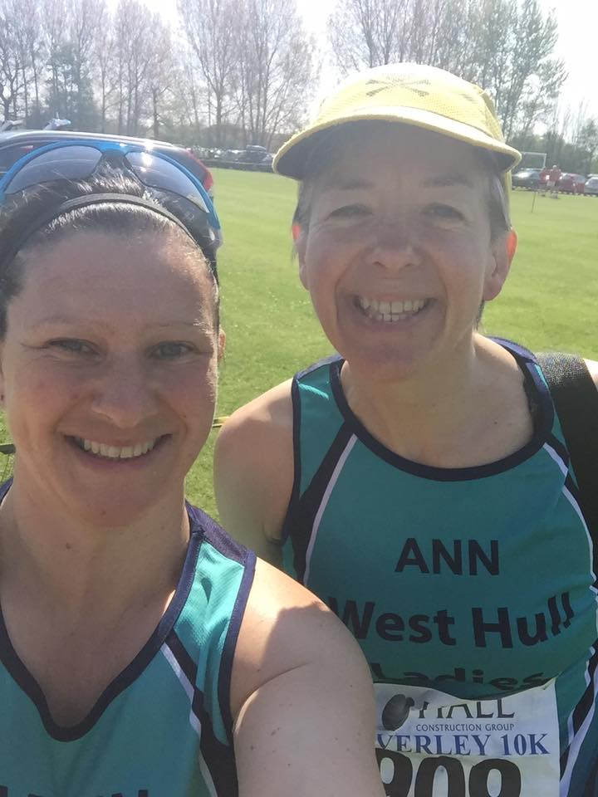

For those of you who don’t know my story, I have run 17 marathons, but an old knee injury finally caught up with me at the end of York marathon, 2014, and I decided to call it a day, and work out how to get my knee fixed. So I rested for most of 2015, then after an arthroscopy in October, the consultant said I’d be good to run, but get some physio first. At that point I sought an appointment with Kris Lecher, and to cut a long story short, several hundred single leg squats later I lined up for my first race for over a year.
It been such a thrill to have been gradually building back up my running distance since last October, and to be running pain-free. Running is such a gift now for me, I feel so privileged and blessed to be putting on my trainers and hitting the roads. So today I decided I would not hold back, I’d give it everything I had and see what shape I am now in.
11.15 came and we were off. It was quite cramped at first, and I did a bit of bobbing about to get past the slower runners, until eventually the route through the Westwood left us all a bit more space to run. Keep working hard, I though to myself, and keep that 55 minute pacer guy behind you. The first hill came soon enough, I was pleased to be able to keep working hard at my pace and got up it quite well. I skipped the water station - I wouldn’t get dehydrated in that short time, so I’m good to keep going. All was well. Yes, it was hot - it was very hot, but then I realised that I’d been far hotter than this doing my 5k dreadmill running at the gym. Once I decided that therefore I was trained for this heat, I relaxed a bit more as I headed toward the second hill. Again I worked hard to keep the pace up, and was delighted to get to the left turn which meant we were heading back to town.
The next bit was the hardest - the crowd was pretty thin at this point, and we still hadn’t quite got the the downhill part back through the Westwood - but keep up the momentum, don’t slacken now - its past half way. Once we reached the Westwood, I knew this was the time to push still further. It was really hard now, because I was tired and we had a bit of a headwind, but it was downhill and I only had a mile or so to go.
Getting back into town was ace - all the people, the noise, the excitement - almost the big city marathon experience … and the cobbles!! Not to worry, with all the conditioning work I’ve done in the gym, my joints are easily able to cope with this uneven surface, and anyway it soon flattened out onto a smoother surface. Hold it, don’t push it yet, this last section is a bit of a slog … now GO!! The final push was ace - I loved having just that little bit of umph left to do a bit of a sprint finish, and overtake two runners into the process! Don’t pass out - keep walking, breathe deep, keep walking, you’ll be fine. AND I finished with watermelon still left - bonus!
I loved it today - every minute, and when it was really hard, I loved it then as well!!
Roll on North Lincs half next week!!
Ann

Top tip: Linda

Great news for runners, Listerine therapy for toenail fungus: Apparently if you soak your toes in Listerine Mouthwash the powerful antiseptic leaves your toenails looking healthy again.

Presentation Evening

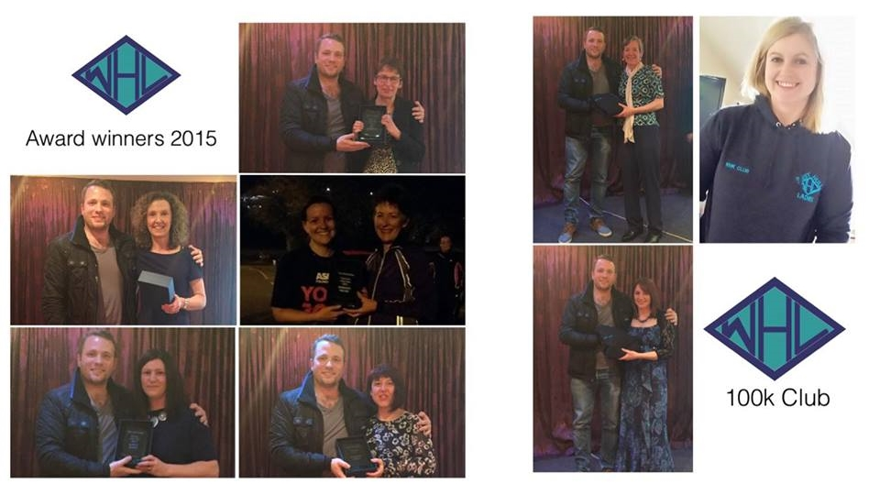

Award Winners: 2016

Clockwise from top right
Most Improved Member: Jill Jameson
Newcomer of the Year: Johanna Plumb
True Grit: Sharron Wiley
Member of the Year: Karen Scott
Ten K Series: Kate Bowers

100 club:
Sally Widdowson
Zoe Jameson
Ann Holmes

Maria’s Amazing Coconut Cake

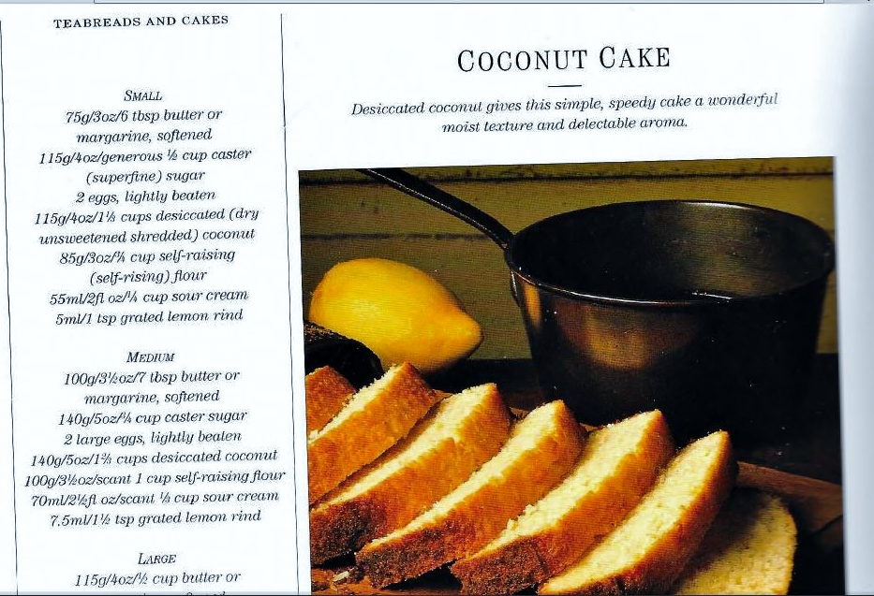
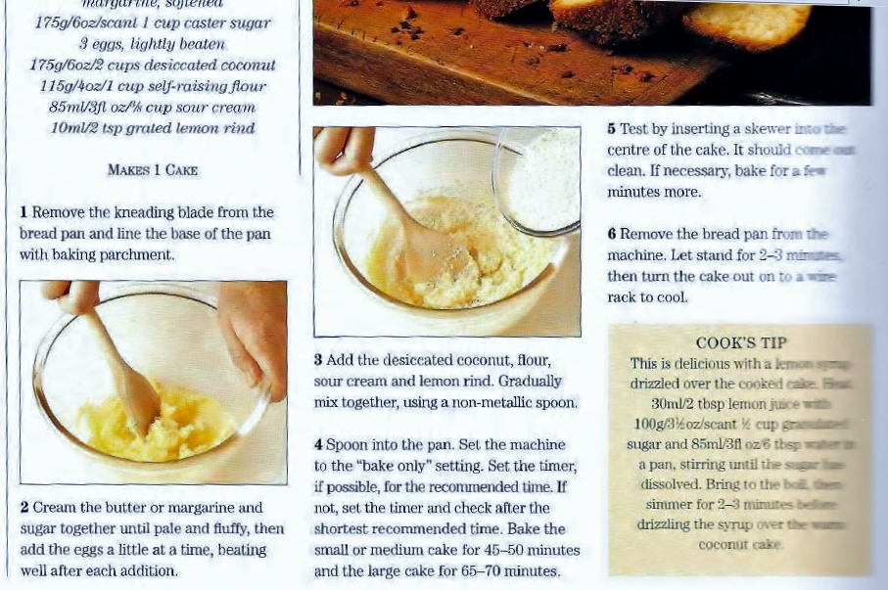

2016 RACE DIARY

Free 5K time trial every Saturday 9am:
Hull Parkrun Peter Pan Parkrun Humber Bridge parkrun

Double check dates, times and entry fees with the official website or the entry form. Zx Website contains all the links to the races: http://westhullladies.org.uk/races.htm

May15th  9:00 | North Lincolnshire Half Marathon | £26 UKA/£28 | Online entries only | Online entry
May 15th | Jane Tomlinson Nottingham 10K | £25.82 UKA/£27.96 | Online entries only | Online entry
May 15th  10:00 | Derwent Dash 10K | £14 UKA/£16 | Online entries only | Online entry
May 17th  19:15 | EHH Summer League East Park 4 Miles | £6 UKA/£8 | Enter on the day | Enter on the day
May 31st 19:15 | EHH Summer League Leven 10K | £6 UKA/£8 | Enter on the day | Enter on the day
June 2016
 | 5th/TBC | Jane Tomlinson Burnley 10K | £21.54 UKA/£23.68 | Online entries only | Online entry
 | 10th/19:30 | Sledmere Sunset Trail 10K | £13 UKA/£15 | Online entries only | Online entry
 | 14th/19:15 | EHH Summer League Sproatley 7 Miles | £6 UKA/£8 | Enter on the day | Enter on the day
 | 19th/TBC | Jane Tomlinson Hull 10K | £24.68 UKA/£26.82 | Online entries only | Online entry
 | 26th/09:00 | Humber Bridge Half Marathon | £22 UKA/£24 | Online entries only | Online entry
 | 28th/19:15 | EHH Summer League Coniston 10K | £6 UKA/£8 | Enter on the day | Enter on the day
July 2016
 | 8th/19:30 | Walkington 10K | £11 UKA/£13 | Online entries only | Online entry opens midday 16th April
 | 10th/10:00 | Caistor 10K | £11 UKA/£13 | Online entries only | Online entry
 | 10th/09:30 | Jane Tomlinson Leeds 10K | £25.82 UKA/£27.96 | Online entries only | Online entry
 | 12th/19:15 | EHH Summer League Skirlaugh 8 Miles | £6 UKA/£8 | Enter on the day | Enter on the day
 | 24th/10:00 | Burton Constable Hall 10K Trail Race | £15 UKA/£18 | Online entries only | Online entry
 | 24th/09:30 | Great Yorkshire Run Harrogate 10K | £19 | Online entries only | Online entry
 | 26th/19:15 | EHH Summer League Hedon 4 Miles | £6 UKA/£8 | Enter on the day | Enter on the day
 | 31st/10:00 | Great Grimsby 10K | £10 UKA/£12 | Online entries only | Online entry
NOTE: Club Vests must be worn at any races you enter
under the West Hull Ladies running club name.

Kit Order Form

NEW STYLE VESTS and HOODIES are purchased direct from www.pbteamwear.co.uk
On website: click on Clubs, Athletics Club, West Hull Ladies RC
Pick your size, name you wish to have on the front and follow payment instructions

For all other purchases use this form.

FORENAME ___________________________________
SURNAME ___________________________________

ORDER - tick what you require and circle your size Price
- OLD STYLE VEST SIZE 10 12 14 16 £15.00 £5.00 (useful for training)
- LONG SLEEVED SIZE 12 14 £18.50 £10.00 (useful for training)

- BEANIE HAT £6.50
- PINLESS WHL NUMBER FASTENERS (set of 4) £3.00

DATE Ordered _______________
AMOUNT PAID _______________

Please transfer payments online with your name and marked as ‘Kit’ to:
Account: 63762742 Sort Code: 20 43 49

Or cheque payable to ‘West Hull Ladies RRC’, and write your name and ‘Kit’ on the back and give to Club Treasurer Linda Dodsworth, 110 The Stray, South Cave, E Yorkshire. HU15 2AL

Sign on receipt of goods _________________________________
DATE _______________

Please complete this form and email to diazmaria@btinternet.com
Thanks.
Maria Kit Officer

